This report is written for the stakeholders at Big Mountain Resort to evaluate the best way to offset the $1.54 million dollars of additional costs associated with a new chair lift, as well as to illustrate the best ways to increase cash flow for future investments.

## Investigation Methods

1. **Data Wrangling:** Investigated data provided to search for missing values and errors in data entry; evaluated if they had any additional useful information or if they would be best left out of the analysis
2. **Exploratory Data Analysis:** Identify what to look for; what features correspond with higher ticket prices, what trends in states similar to Montana, what market drivers exist in our particular market.
3. **Model Design and Evaluation:** Tested both a linear model and a random forest regressor model and evaluated their performance with both the mean squared error and the mean absolute error, and found that the random forest model had a noticeably lower mean absolute error than the linear model based on the test data. Random forest models take up more computing power and data storage, but given the size of the dataset provided the benefits outweigh the disadvantages. The random forest model could be deployed as a web app on the company intranet for testing other variables as the markets shift over time.

## Model Findings

*These findings are based on the information provided and have been tested rigorously. They are still predictions, and not guarantees.*

**Increase Revenue**

|  |  |
| --- | --- |
| *Where We Are* | *Where We Could Be* |
| * Top price for Montana resorts | * Increase by $5-$15 and stay comparable nationwide   + Top 10% for Number of Runs, Longest Run, Total Chairs, Skiable terrain, Snow Making   + Top 15% for Vertical Drop * Pros: No additional operating expense or expenditure needed * Cons: Already the highest price in Montana, customers may look elsewhere if we aren’t giving them anything more for a higher ticket price |

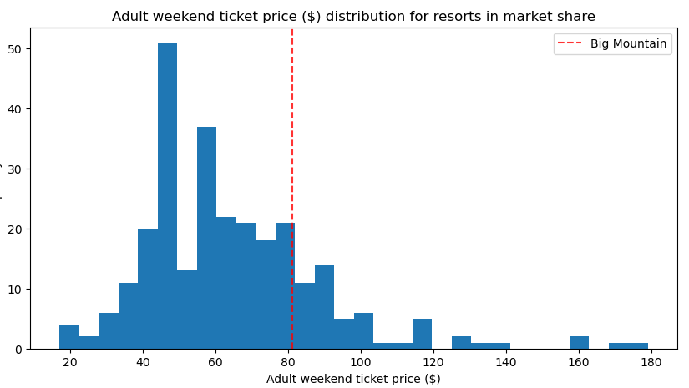

Number of resorts

**Increase Value to Justify Price Increase**

|  |  |
| --- | --- |
| *Where We Are* | *Where We Could Be* |
| * Top 15% of resorts nationwide for vertical drop | * Increase Vertical Drop by 15 feet, add a run, install additional chair lift   + All features with clear correlations to ticket price * Additional value of suggested changes would justify add’l $1.99 per ticket / $3.47m per season * Pros: Significant increase for minimal expenditure * Cons: Incomplete data on operating expenses, actual profit after increasing both costs and revenue has not been calculated |

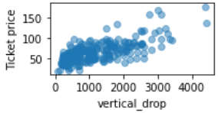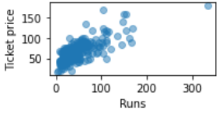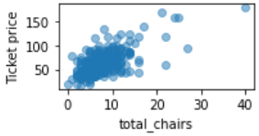

**Cost Reduction: Close least used runs**

|  |  |
| --- | --- |
| *Where We Are* | *Where We Could Be* |
| * Top 10% of resorts nationwide for most runs | * No value lost at closing 1 run * Minimal value lost at closing 2-5 runs * Still in top 10% with 5 runs closed * Pros: No additional operating expense or expenditure needed * Cons: Customers would perceive the loss in value of their ticket and might look elsewhere |

## 

## Limitations/Additional Information Needed

* How many in-state vs out-of-state customers? Are most customers coming from out of state to avoid the higher ticket costs back home?
* When was Big Mountain’s last price increase, and what changes (if any) did they make to justify it?